Lab01 PyTorch Self-Study – Vibe coding
Instruction: Create this neural network in PyTorch and run a forward pass, then find the output tensor sizes
1. Demo code in .ipynb with comments and a screenshot image with showing the print of all tensor size in each layers.
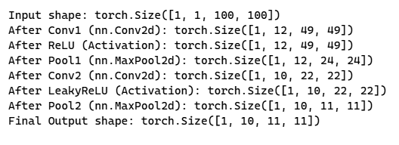

2. Fill in the blank of Output tensor size in the table.
Layers, Operations | Hyperparameters | Output Tensor size (w, h, channel)
1. Input matrix | 100 x 100 x 1 (w, h, channel) | 100x100x1
2. 2D - Convolution | Kernel size: 4x4  Filters counts: 12  stride=2, padding=0 | 49, 49, 12
3. ReLU activation function |  | 49, 49, 12
4. Max-Pooling | Kernel size: 2x2 | 24, 24, 12
5. 2D- Convolution | Kernel size: 3x3  Filter counts: 10  stride=1, padding=0 | 22, 22, 10
6. Leaky_relu activation function |  | 22, 22, 10
7. Max-Pooling | Kernel size: 2x2 | 11, 11, 10

